|  |
| --- |
| Ciconi’s Games |
| **AIRFIRE** |
| **Space War** |
| Andre Lemos, Fabio Ciconi and Rodrigo Geronimo  Version #1  All work Copyright © 2017 by Ciconi’s Games.  All rights reserved. |
| **Andre Lemos, Fabio Ciconi, Rodrigo Geronimo** |
|  |

|  |
| --- |
| August 04th 2017 |

**Table of Contents**

Contents

Version History 3

1. Game Overview 4

2. Game Play Mechanics 4

3. Camera 4

4. Controls 4

5. Saving and Loading 4

6. Interface Sketch 5

7. Menu and Screen Descriptions 5

8. Game World 5

9. Levels 6

10. Game Progression 6

11. Characters 6

12. Non-player Characters 6

13. Enemies 6

14. Abilities 6

15. Vehicles 7

16. Story Index 7

17. Future Features 7

# Version

Version 1.0 – Document start

Version 2.0-Create the stage 2

# Game Overview

Are you prepared to face the best adventure of your life? You need to protect planet earth from asteroids and other enemies. Embark on the AirFire007 ship and do not let the land be destroyed. When the earth loses the ozone layer you do not have another option, you need to save your planet from the aliens. AirFire007 is an amazing space ship, it is fast, powerful and can destroy everything with the powerful shoot blue ball explosion. you will escape this war, prepare your helmet that AirFire007 is waiting for you.

# Game Play Mechanics

The mechanic is simple; the player needs to eliminate the asteroids and kill the wave of enemy ships. The player needs to define what is the best position to stay to defeat the enemy ships and escape the asteroids. The player can destroy the ships with fire and the asteroids they can escape or destroy.

# Camera

The game uses a 2D side-scroller, the camera does not change position.

# Controls

The game uses a simple up, down, left and right keyboard buttons and space bar to fire.

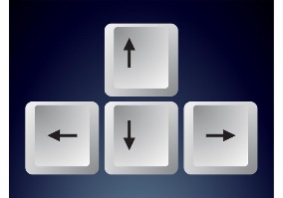

# Interface Sketch

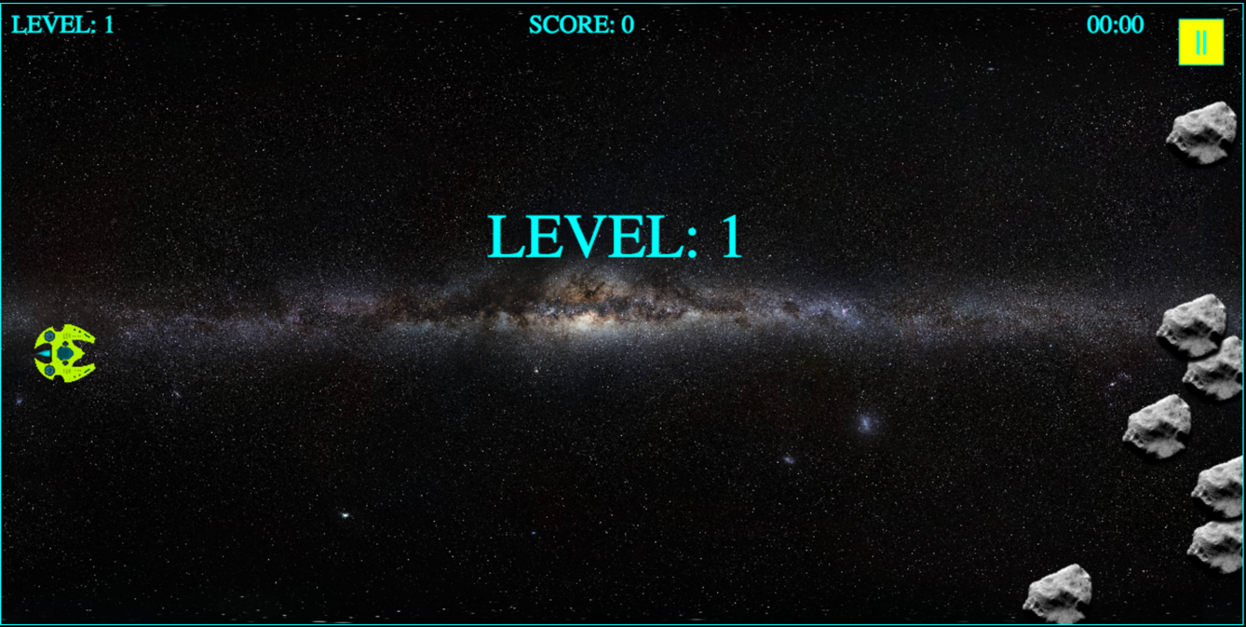

Scream shoot of the game in level 1 when the level is start.



Scream shoot of the game in level 1 when the player play.

Scream shoot of the game in level 2.

# Menu and Screen Descriptions

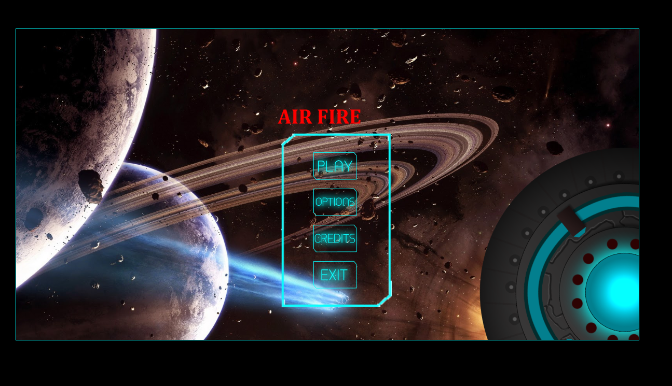

The main menu is divided in four options play, options, credits, and exit.

* Button play is for start the game.
* Button options is for change the control.
* Button credits is for informer about the creator.
* Button exit is for close the game.



The game over menu appear when the player loses the game. The game over menu is divided in two options main menu and play again.

* Button main menu is for the play comeback to main menu.
* Button play again is for start the game again.

# Game World

The game happens in 2100 and the humankind remains living on earth. However, we discovered that life in universe life beyond us. Some aliens are peaceful, but other are extremely dangerous. Second, the earth lost ozone layer and we humanity face some problems with asteroids.

# Levels

The game has 3 levels.

The level 1 the player only fight against asteroids. The player can diverge for the asteroids or destroy them. However, the mission of the level 1 is destroy such number of asteroids.

The level 2 the player face asteroids and enemy’s ships, who going to shoot to destroy the player. The player can diverge for the asteroids or destroy but he need to destroy the enemy’s ships.

The level 3 the player face asteroids, enemy’s ships and the enemy mother ship. The same way for level 2 the player need to defeat the enemy’s.

# Game Progression

1. The first level is easy, the player only destroys asteroids.
2. The second level start to become more difficult. The player destroys asteroids and enemy’s ships, but the enemy will try to destroy the player too. The game on this part became more challenge for the player. We classify this level with normal difficulty.
3. The level 3 is the final level and the harder. The player will face the all the enemies but now the mother ship who call the boss enemies ship will going to appear. The player need to defeat everyone to win the game.

# Non-player Characters

The game doesn’t have control in the enemies and space.

# Enemies

Asteroid

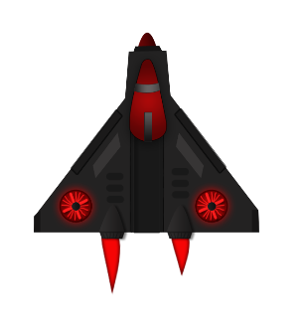Alien space ship

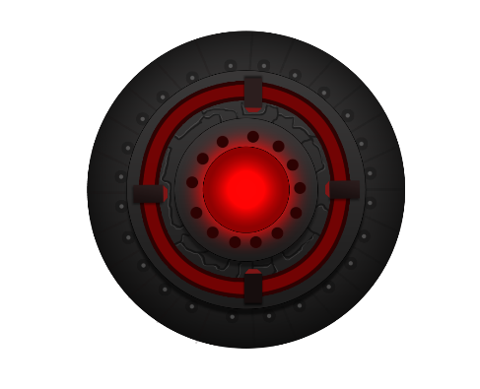Mother alien space ship

# Abilities

The space ship has the ability to shoot to destroy the asteroids and aliens.

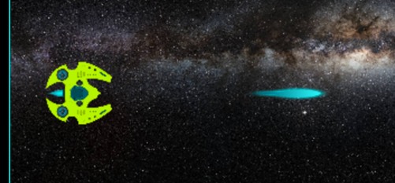 Sprite sheet for the space ship shoot

# Vehicles

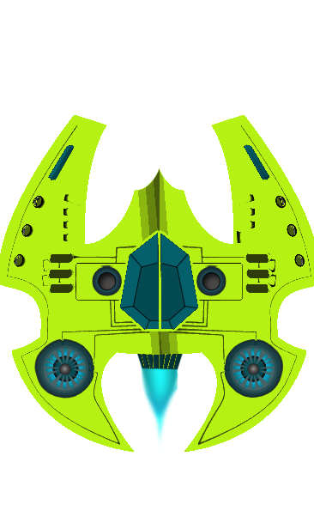Space ship

# Story Index

The galaxy protects recruit new pilots to protect the earth. The mission of the new pilots is to destroy the asteroids and enemy’s spaceships.

# Future Features

The game going to implement the alien in stage 2. Second, in stage 3 we are going to implement the mother alien spaceship that will be the final boss of the game.